IHCI Project Phase 1

# Rules

* Submit a Google Doc, NOT a PDF or a Google slide.
* Use the default fonts, line spacing, and font size unless specifically required in the assignment.
* After submission, the Google Doc will get automatically locked, so you won't be able to make any changes.
* Standard plagiarism rules apply.
* Your submission will not be considered for grading and feedback if you do not follow these guidelines.

**Names of Group Members: Riya Sachdeva**

**Rohak Kansal**

**Rohan Beriwal**

**Rohan Devgon**

**Rohan Indora**

**Project Group Number: 3**

**HCI Group No.: 6**

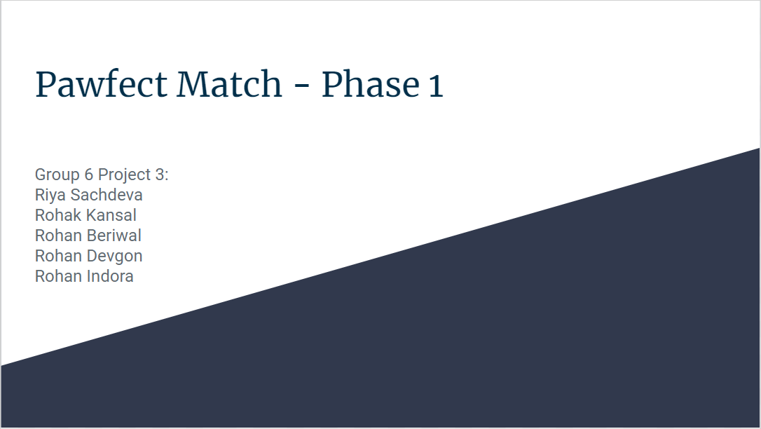

## Requirement Gathering

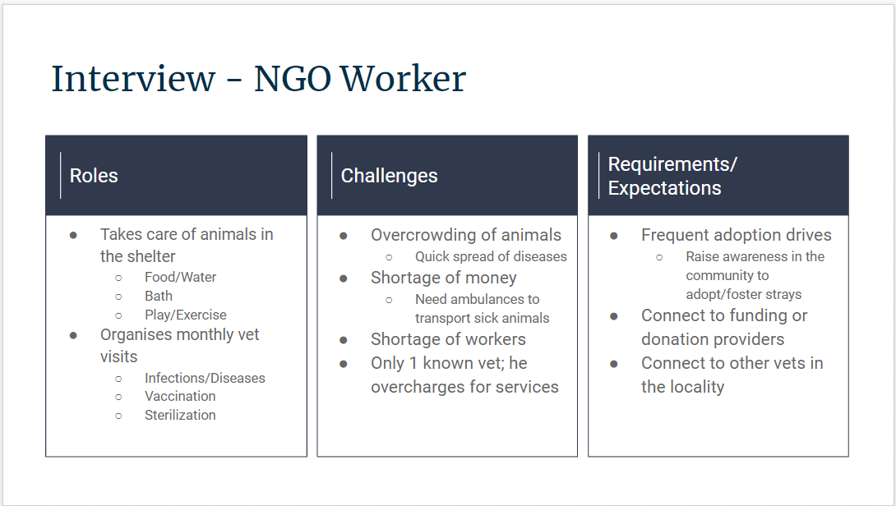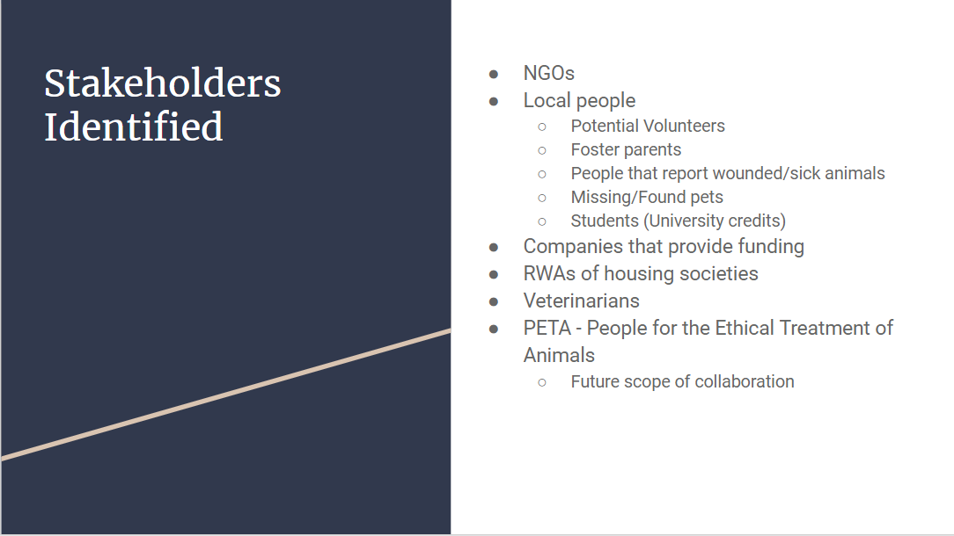

## 

## 

## 

## 

## 

## 

## 

## 

## 

## 

## 

## 

## 

## 

## 

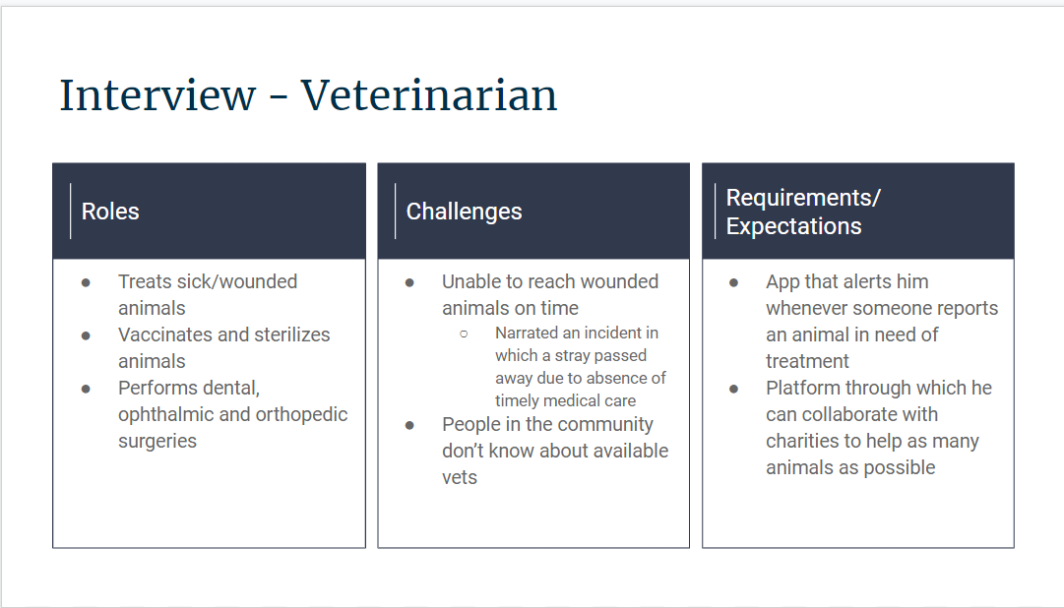

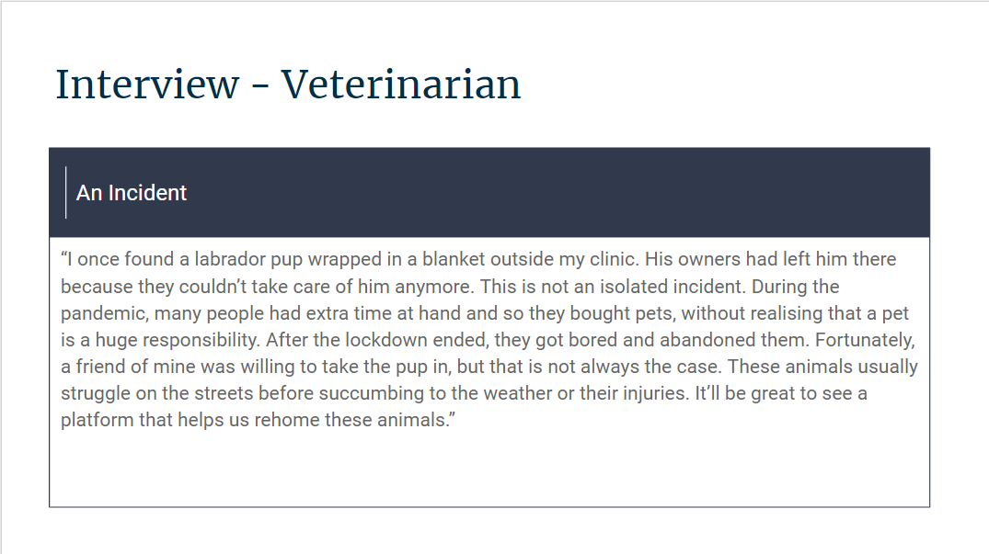

Empathy maps: [Quick Retrospective, Online Whiteboard for Visual Collaboration (miro.com)](https://miro.com/app/board/uXjVP3YRO74=/)

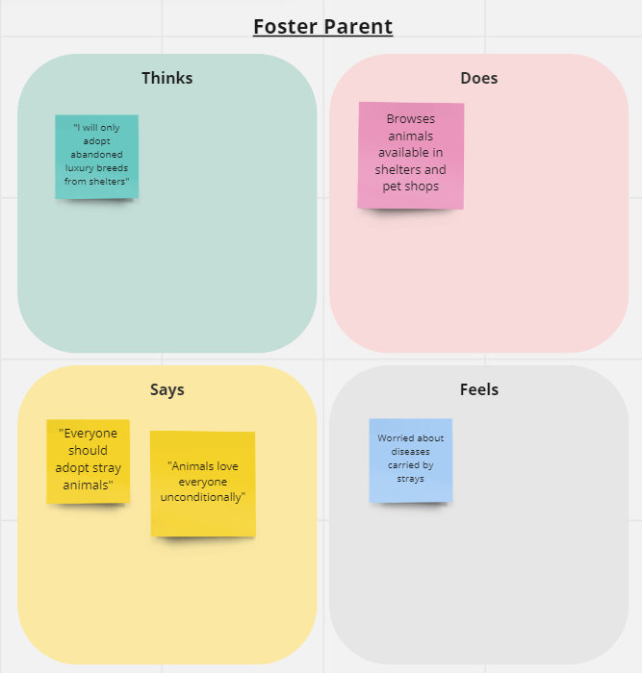

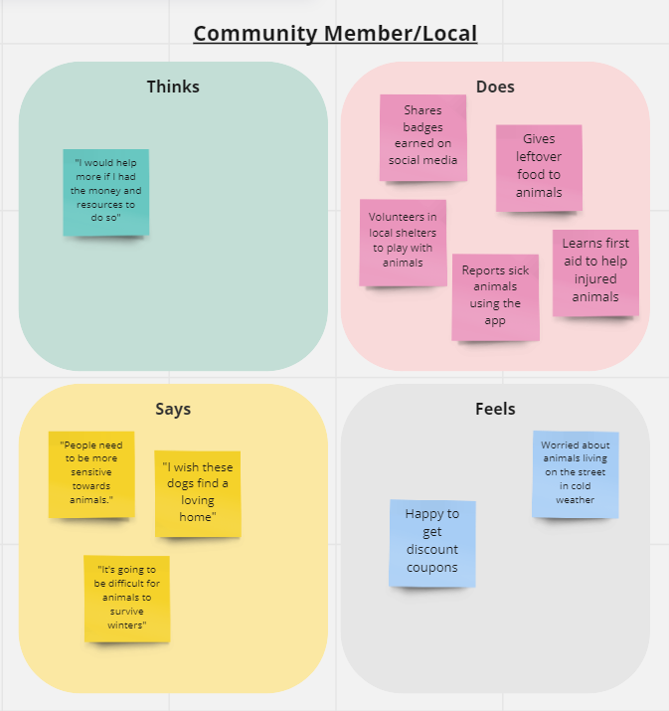

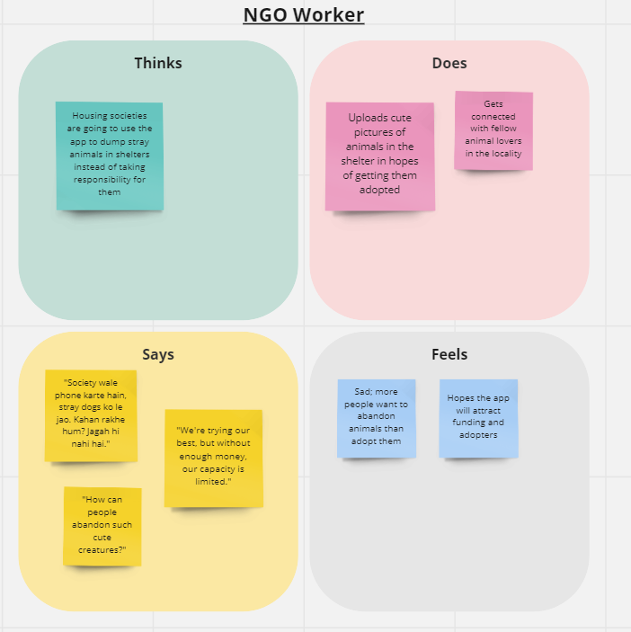

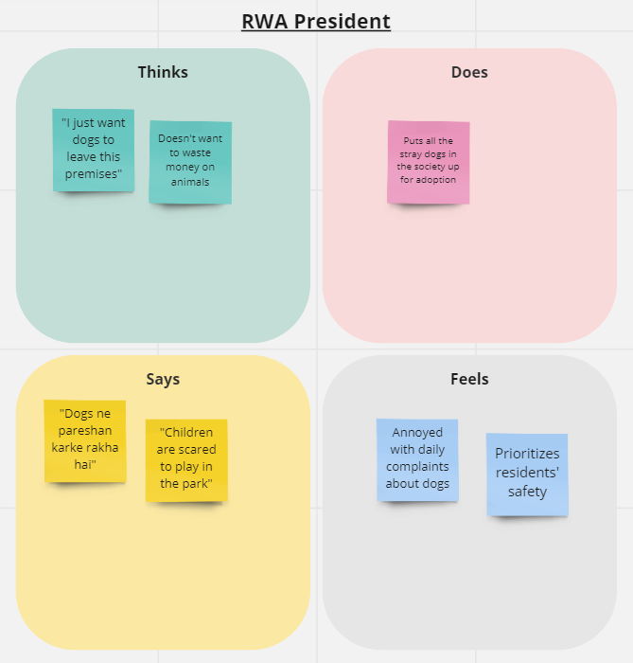

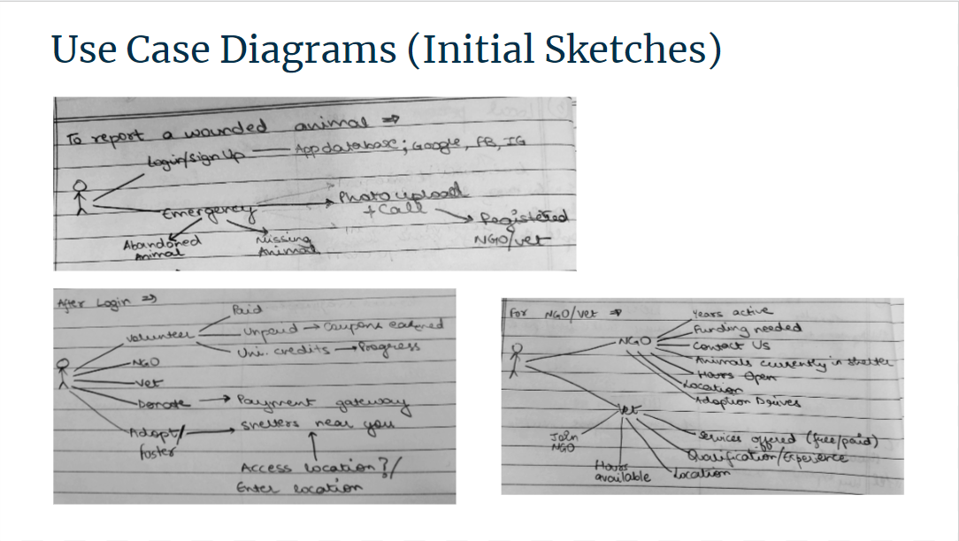

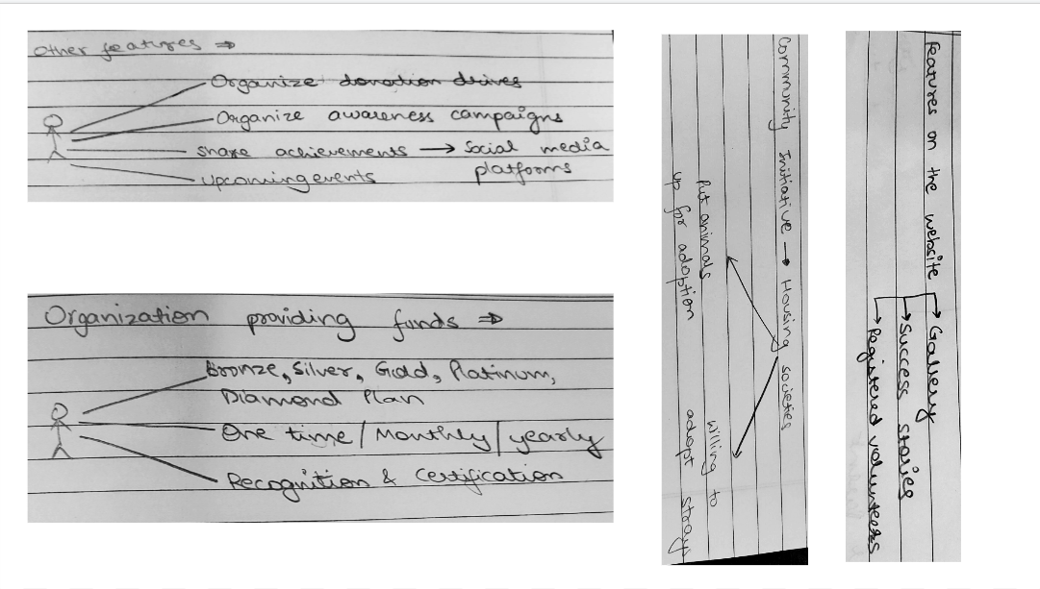

## Personas and Scenarios

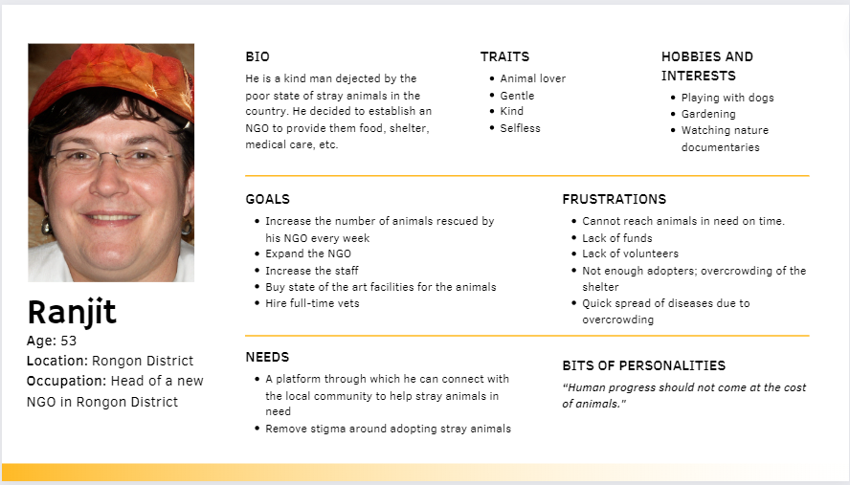

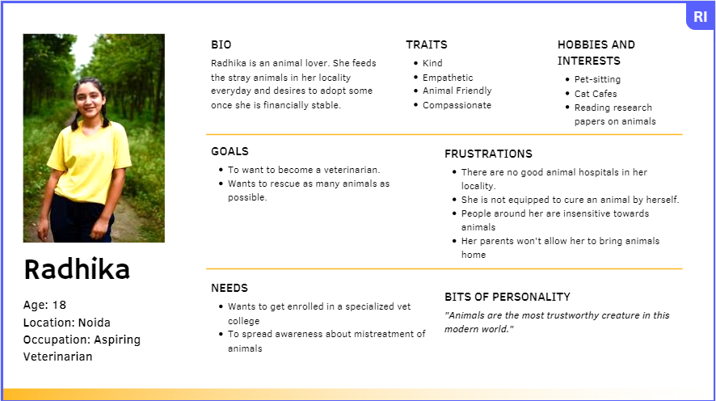

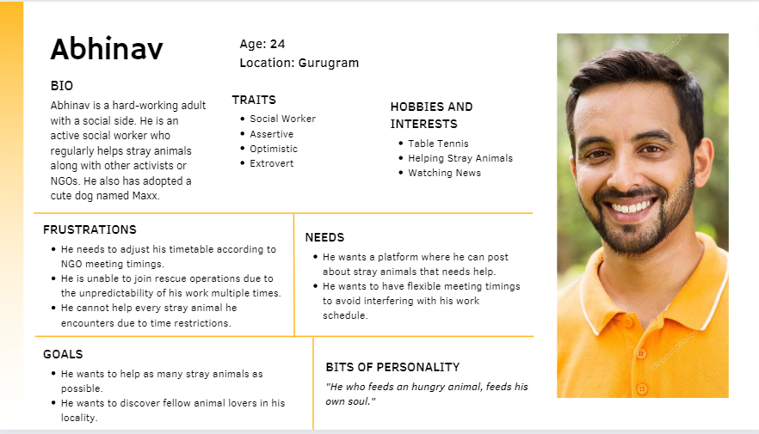

## Problem Understanding

## 

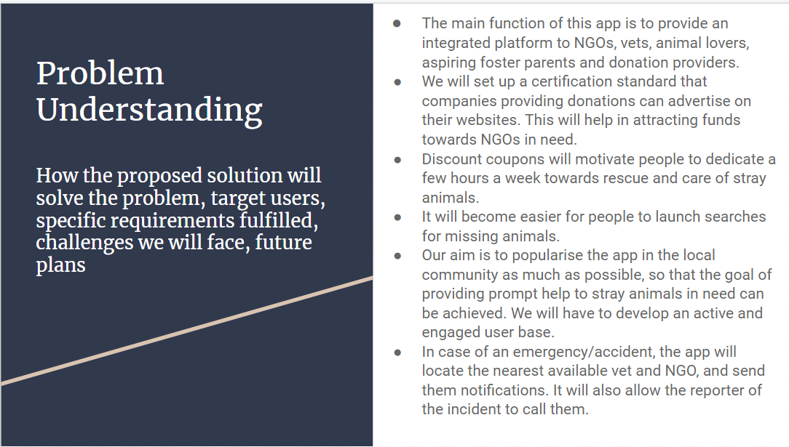

## 

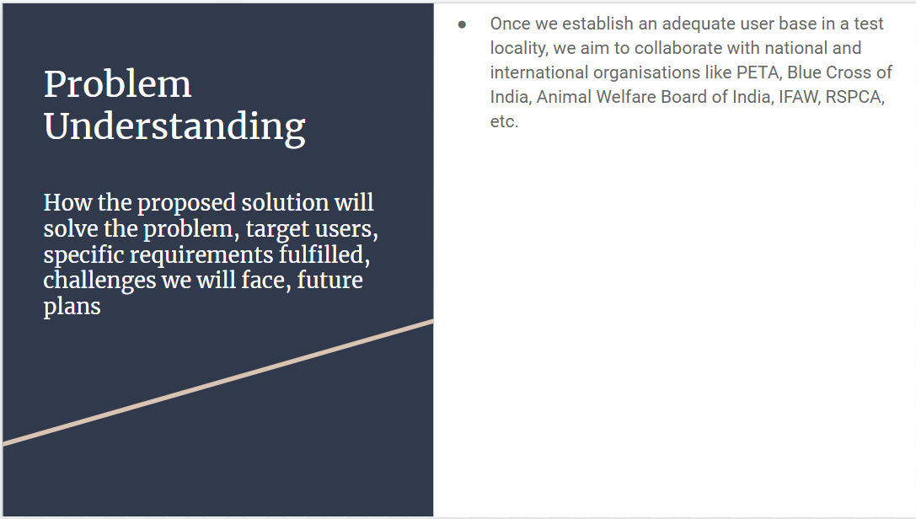

## Contributions

Requirement Gathering - Riya Sachdeva

Personas - Rohak Kansal, Rohan Indora

Problem Understanding - Rohan Beriwal